CN LAB 3
24k-0810
Q1
Task 1: Design the required network topology using a Router, two Switches, PCs, and servers. Assign the specified static IP addresses to all devices according to the given addressing scheme.
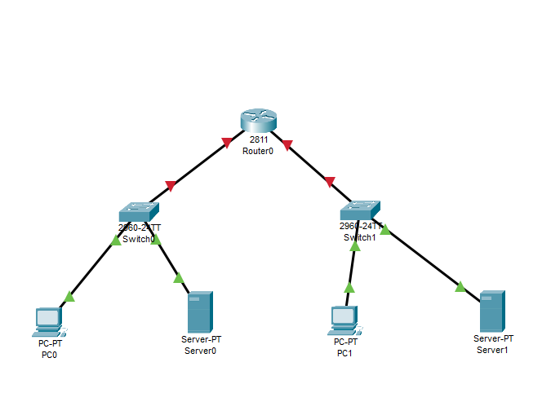

Task 2: Configure the router interfaces with the following IP addresses and ensure that both interfaces are operational:
● FastEthernet0/0 → 10.10.10.1
● FastEthernet0/1 → 172.16.10.1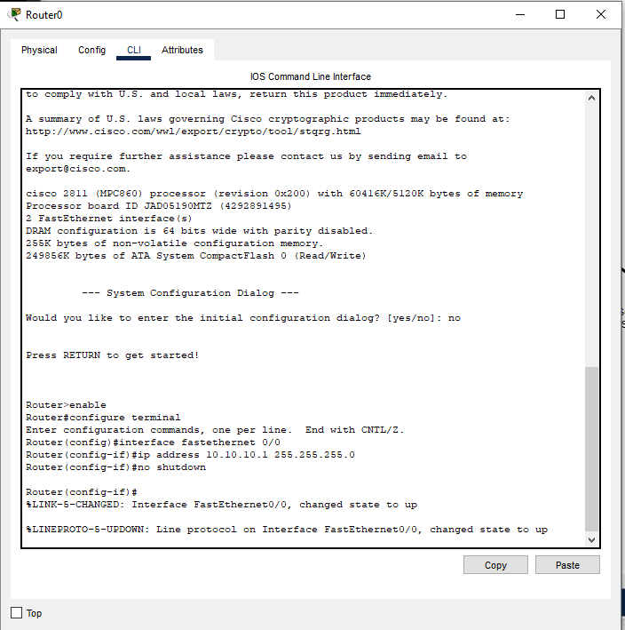

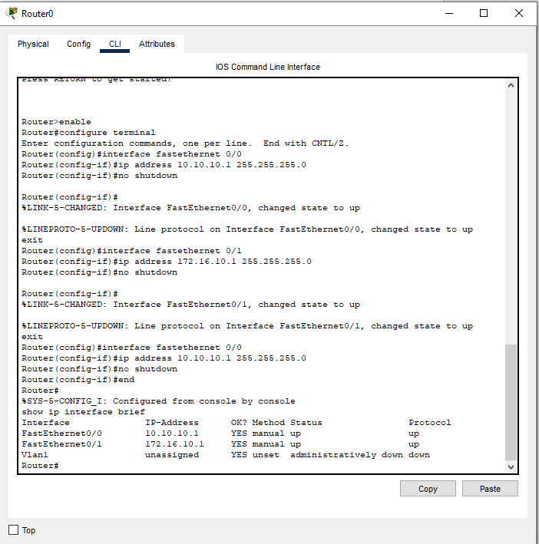
Task 3: Test connectivity between the devices on both networks and verify that communication through the router is successful.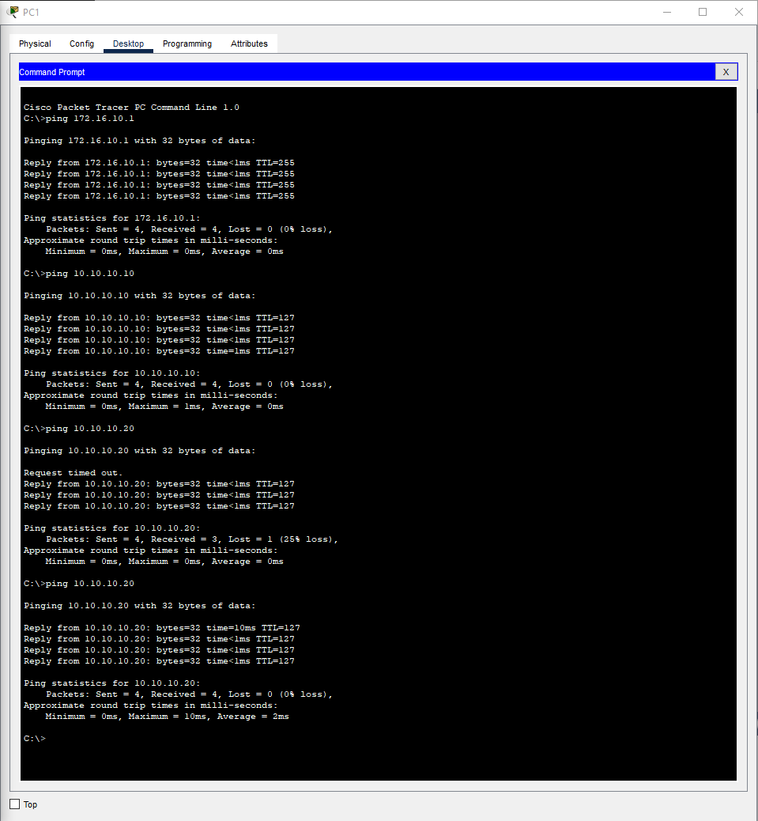
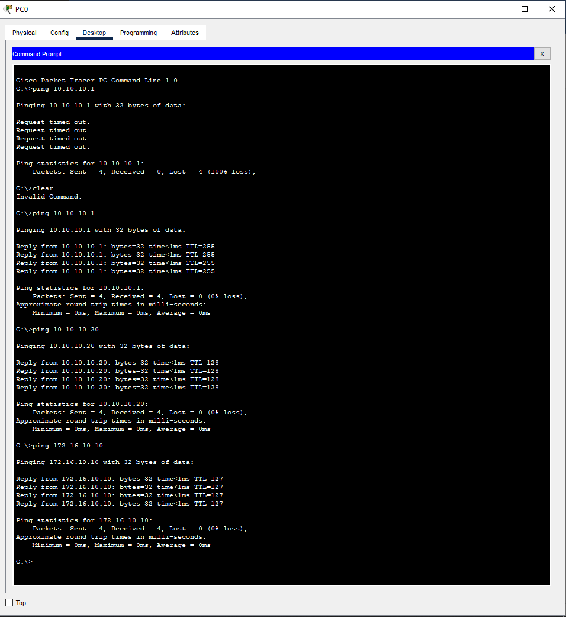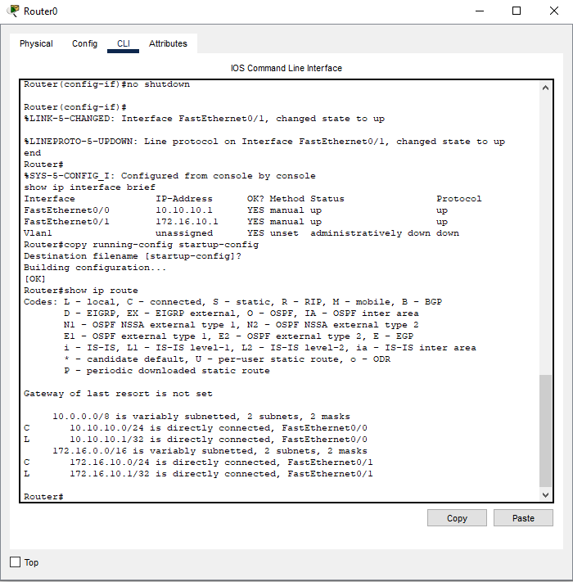

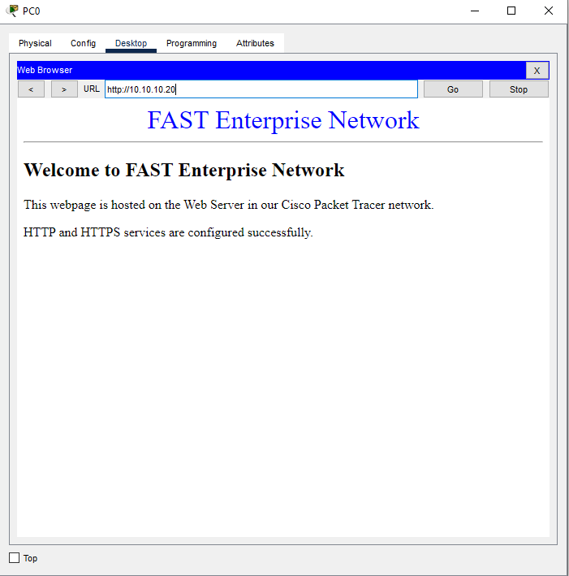
Task 4: Modify the index.html file on the Web Server by adding or changing the webpage content. Save the changes and verify from a PC that the updated webpage is displayed correctly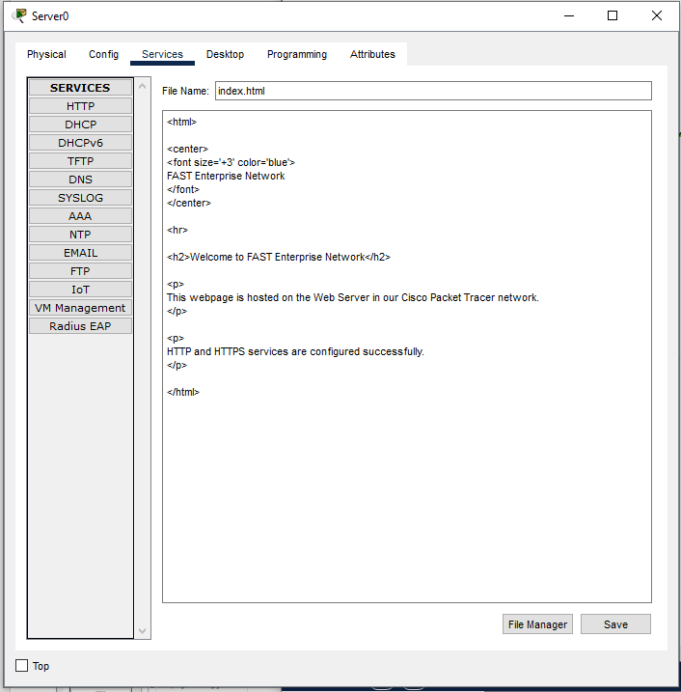

Task 5: Enable the HTTP service on the Web Server and access the webpage from a PC using the server&#39;s IP address. Verify that the webpage loads successfully.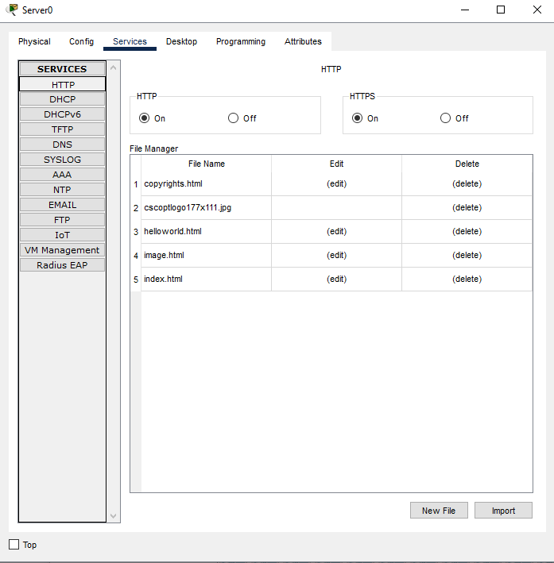

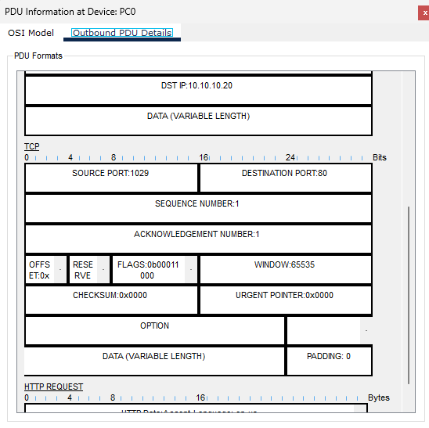
Task 6: Use Simulation Mode to capture HTTP traffic generated by the PC. Examine the captured packet and verify that the HTTP communication uses Destination Port 80.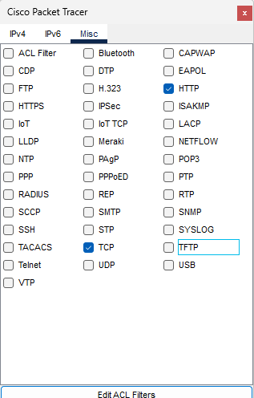

Task 7: Enable HTTPS access to the Web Server and access it from a PC using its IP address. Capture the HTTPS communication in Simulation Mode and verify that it uses Destination Port 443.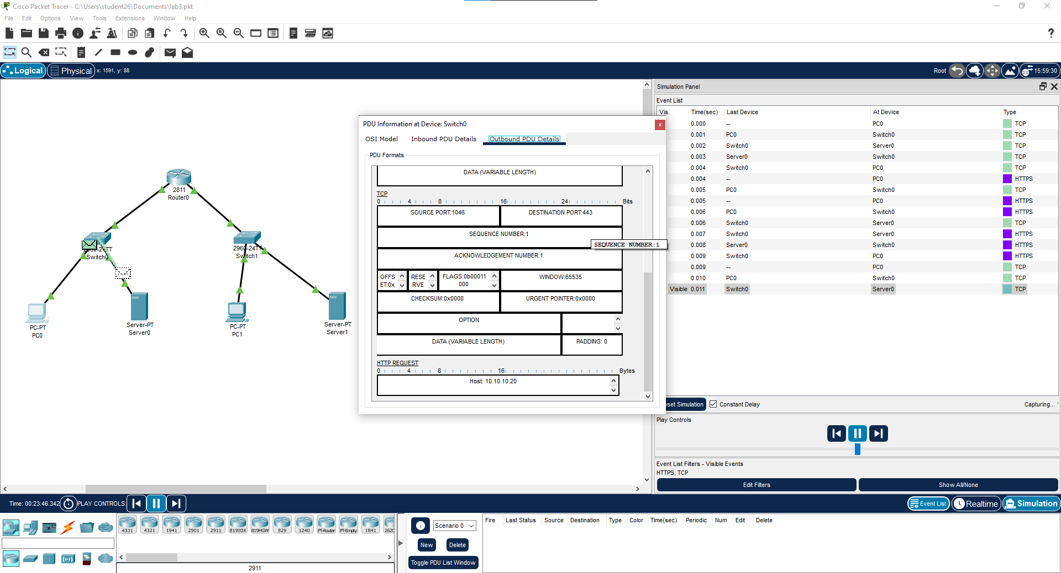
Task 8: Set up a separate DNS environment with the DNS Server using IP address 35.0.0.1. Configure the PCs to use this DNS Server for name resolution.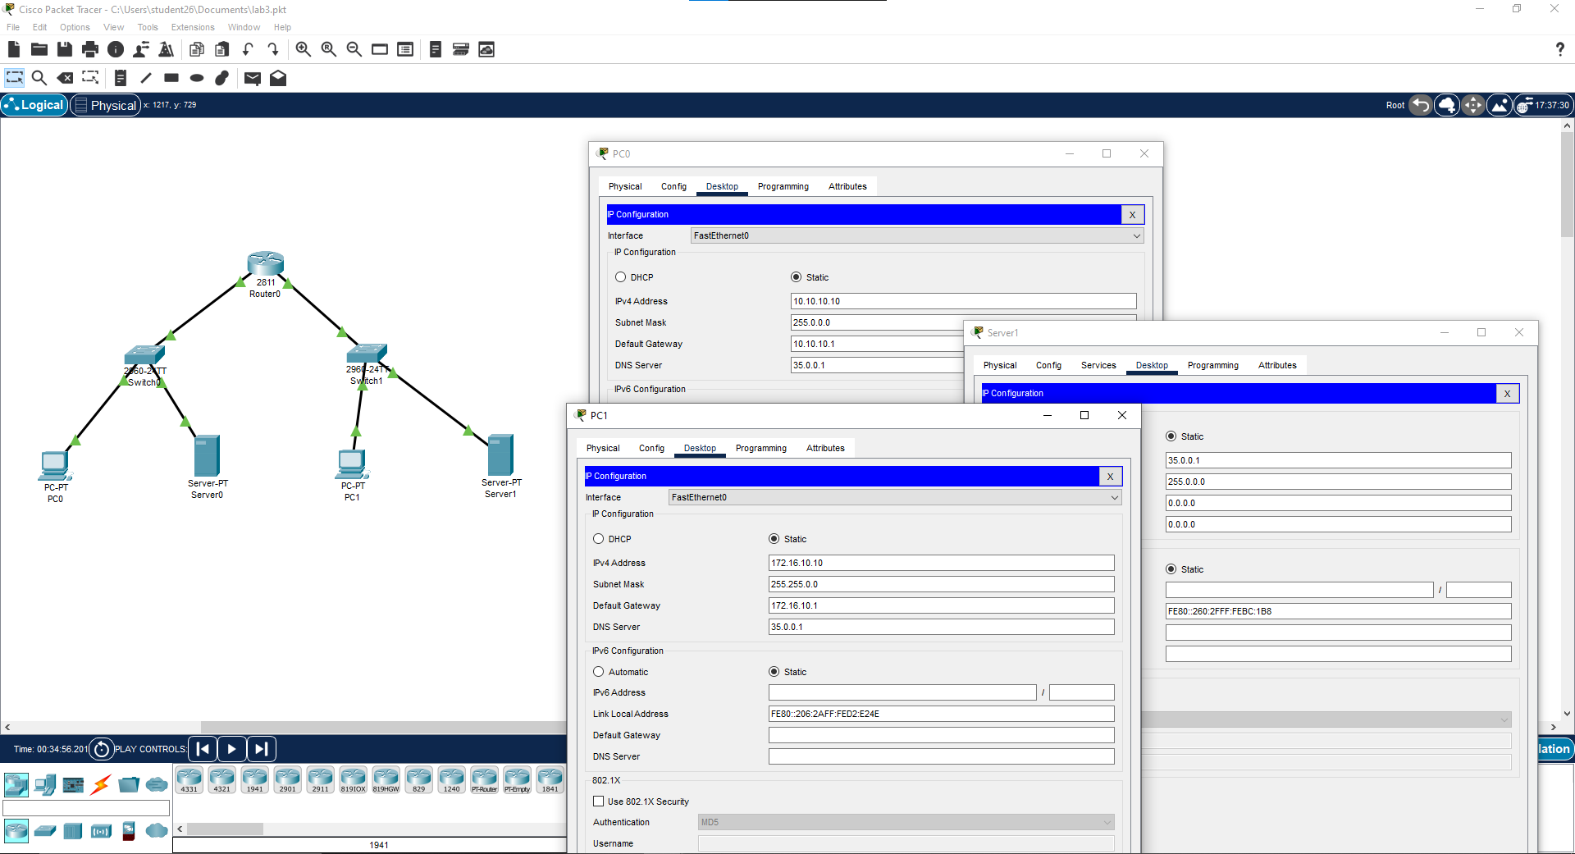
Task 9: Create an A Record that maps fast-ai to 35.0.0.1 and a CNAME Record that maps fast to fast-ai. Test both names from a PC and verify successful name resolution.
Task 9 cannot be completed as specified because the DNS Server is configured with the IP address 35.0.0.1, while the DNS records are required to map fast-ai to 35.0.0.1. This means the hostname resolves to the DNS Server's own IP address rather than the Web Server's IP address. Therefore, testing fast-ai and fast from a PC cannot verify access to the Web Server as intended.
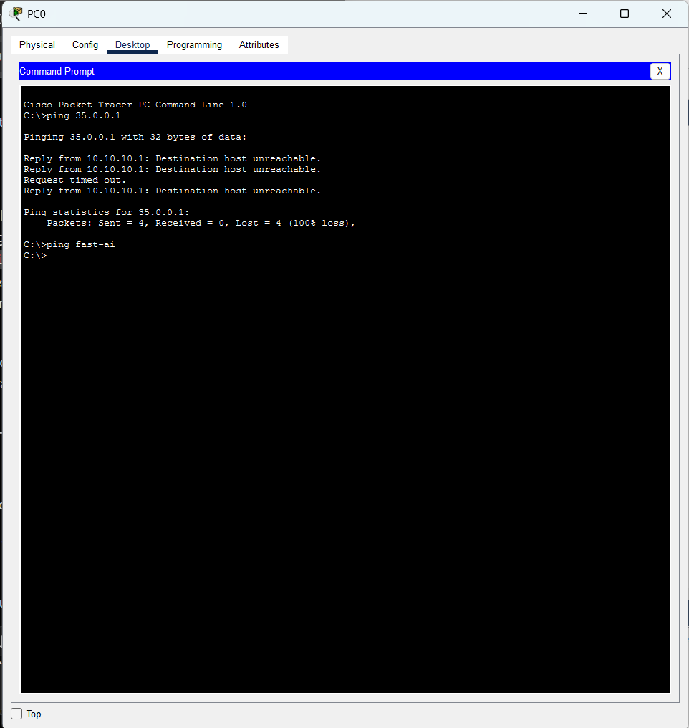

Task 10: Use Simulation Mode to trace the complete communication process. Observe the DNS request and response, followed by the TCP connection and HTTP/HTTPS communication between the PC and Web Server.